STUDOR DS SCREENING PROJECT
PathAI Engine — Take-Home Assessment

1 Executive Summary

1.1 Overview
This report presents a production-oriented PathAI prototype built on one semester of OULAD data. The system combines three outputs: a weekly engagement score, a Week 6 disengagement model, and a next-course recommendation engine.
- Task 1 produces a dynamic 0-100 engagement score from behavior and assessment signals.
- Task 2 predicts Withdrawn/Fail versus Pass/Distinction using only Week ≤ 6 information and converts risk into intervention tiers.
- Task 3 recommends top-3 modules using both collaborative filtering and a shared feature-space content model.

1.2 Results
- Task 1 - Behavioral Engagement Scoring
The weekly 0-100 score uses activity volume, consistency, recency gaps, resource diversity, course-pace alignment, and assessment behavior. Archetypes translate those signals into recognizable patterns such as steady engagers, early dropouts, late recoverers, burst engagers, procrastinators, compliance engagers, and opportunistic engagers.
- Task 2 - Disengagement Prediction And Staff Alerts
The selected model is XGBoost, trained only on Week ≤ 6 features. The headline result is a strong ranking model (ROC-AUC 0.870) converted into three operational tiers: a precise high-touch advisor queue, broader light-touch behavioral nudges, and passive monitoring.
- Task 3 - Course Recommendations
The recommender compares collaborative filtering against a shared feature-space content model. The content model matches student Week 6 profiles to course profiles using cosine similarity, blended with a Wilson lower-bound pass-rate prior for a conservative cold-start solution.
Overall result: the prototype is credible enough for a 90-day decision-support pilot. The strongest product insight is how model outputs are converted into workflows that advisors can act on without creating alert fatigue.

2 Data Cleaning
The cleaning philosophy is conservative: preserve the official OULAD outcome label, audit semantic inconsistencies, and use imputation only inside model preprocessing. This matters because careless cleaning can accidentally leak future information or rewrite the target.

2.1 Consistency Checks
Issue | Issue Count | Decision | Reason
Enrolment key | 0 | Use student + module + presentation | Student ID alone is not unique across modules/presentations.
Unregistered but not Withdrawn | 9 | Audit only; keep official final_result | Avoids silently changing the supervised target.
Withdrawn without unregister date | 93 | Do not use date_unregistration | The date can occur after Week 6 and would leak future status.
Missing score rows | 173 | Keep missing; median-impute in model | Separates data quality from modelling assumptions.
Assessment due date missing | 11 | Exclude from due/submission features | Cannot safely determine Week 6 availability.
Negative VLE dates | 688988 | Treat as pre-start engagement | They represent activity before day 0, not bad data.
Missing VLE week metadata | 10486 | Do not use as direct features | Prevents unstable metadata from driving the model.
The dataset was cleaned conservatively to avoid changing the meaning of the prediction task. Each enrolment was defined using student, module, and presentation to prevent duplicate or incorrect merging. Missing scores were kept and handled through imputation, while unreliable fields such as unsafe unregistration dates or missing assessment deadlines were excluded from feature engineering.

2.2 Leakage Controls
Candidate feature | Available Week 6? | Used? | Reason
Pre-start VLE activity (negative dates) | Yes | Yes | Observed before day 0; reflects eagerness to begin course materials.
Week 1-6 VLE clicks | Yes | Yes | Observed before the Week 6 prediction point.
Week 1-6 active days | Yes | Yes | Observed before the Week 6 prediction point.
Week 1-6 activity diversity | Yes | Yes | Observed before the Week 6 prediction point.
Early non-exam assessment submissions | Yes | Yes | Only due/submitted work by Week 6 is used.
Student demographics/context | Yes | Yes | Known at registration or course enrolment.
Engagement score | Yes | Yes | Computed from Week 1-6 behavior using train-derived score weights.
Final result | No | Target only | Used only to train/evaluate the supervised label.
Final exam score | No | No | Not available by Week 6.
Full-semester total clicks | No | No | Would leak future engagement behavior.
date_unregistration after Week 6 | No | No | Would leak withdrawal timing/outcome.
For Task 2, only information available by Week 6 was used as model input. Early VLE activity, assessment submissions, demographics, and the engagement score were included because they are available before the prediction point. Future-looking variables such as final exam score, full-semester clicks, and post-Week 6 unregistration dates were excluded to prevent data leakage.

3 Task 1: Behavioral Scoring Framework

3.1 Approach
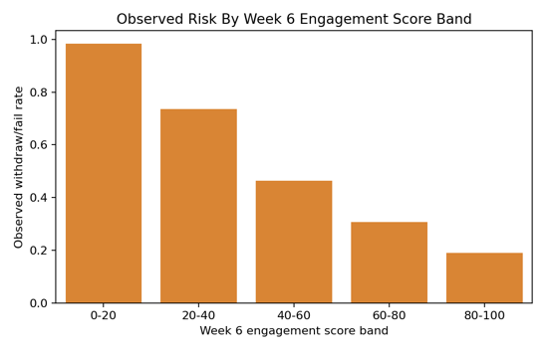
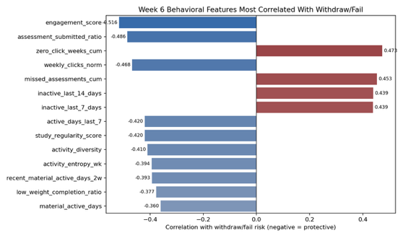
Task 1 builds a weekly 0-100 engagement score at the enrolment-week grain. Components are peer-normalized within module, presentation, and week, then weighted by how well they separate successful students from Withdrawn/Fail students on the training split. This keeps the score comparable across modules without pretending that every module has the same baseline click intensity. I constructed weekly behavioral features, normalized by module-presentation-week peers, and aggregate with train-derived weights. Components with weak train signal are assigned zero weight.
Component | AUC | Weight
Peer-normalized click volume | 0.774 | 15% | 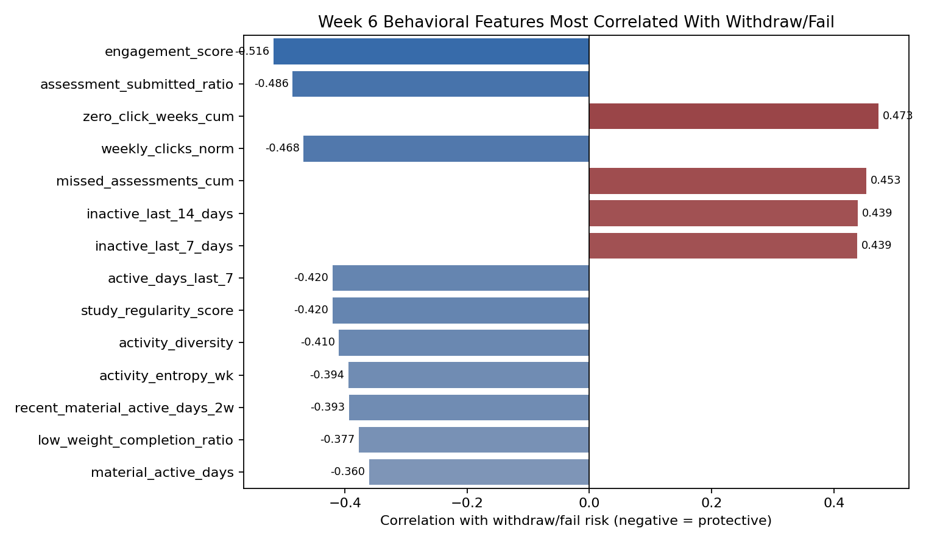
Module-material study frequency | 0.741 | 15%
Activity diversity | 0.762 | 15%
Recent activity | 0.773 | 15%
Pre-start course material engagement | 0.690 | 10%
Active-day consistency | 0.778 | 10%
Assessment completion | 0.718 | 10%
Low-weight assignment completion | 0.684 | 10%
Three-week trend | 0.481 | 0%
Assessment punctuality | 0.469 | 0%
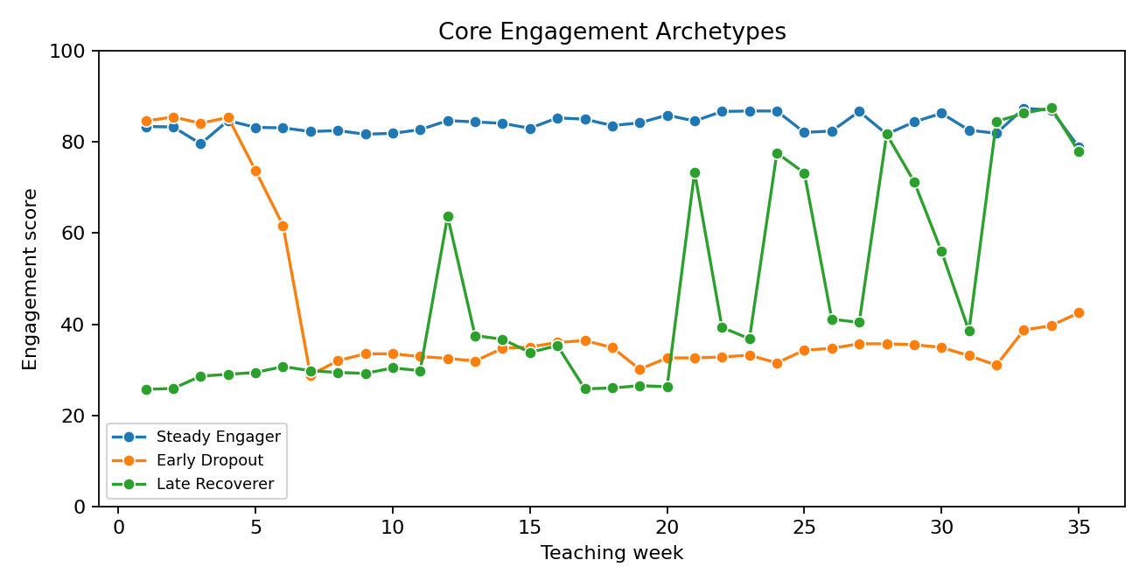
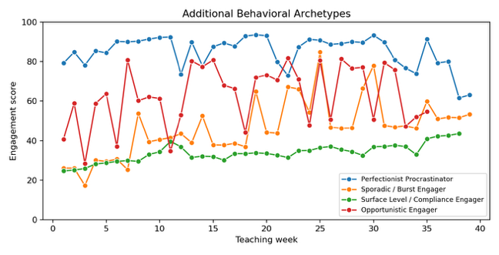
I introduced 4 more representative student archetypes above the baseline 3 that was given in the task. Their brief description is below.
Archetype | Feature signature
Steady Engager | High mean engagement score, low score volatility, strong active-day consistency.
Early Dropout | Sharp negative early-to-late score delta, low late score, often withdrawn final result.
Late Recoverer | Large positive score delta from early weeks to late weeks.
Burst Engager | High score range, high max score, and several zero-click weeks.
Perfectionist Procrastinator | Successful/high-scoring enrolment with late submissions and lower punctuality.
Surface Level Engager | High assessment completion but low activity diversity and low material-study frequency.
Opportunistic Engager | High material-click share and engagement spikes, but weaker active-week consistency.

3.2 Overall Findings
The engagement score shows a clear risk gradient: low score bands are strongly associated with withdraw/fail risk, while the 80–100 band has much lower observed risk. The strongest Week 6 signals are assessment follow-through, zero-click weeks, click volume, inactivity gaps, and active-day rhythm. Weaker components such as trend and punctuality are kept as context rather than major score drivers. Final weights are train-derived, with non-predictive components capped at zero, and archetypes are added to make the score easier for advisors to interpret.

4 Task 2: Predictive Disengagement Model

4.1 Approach
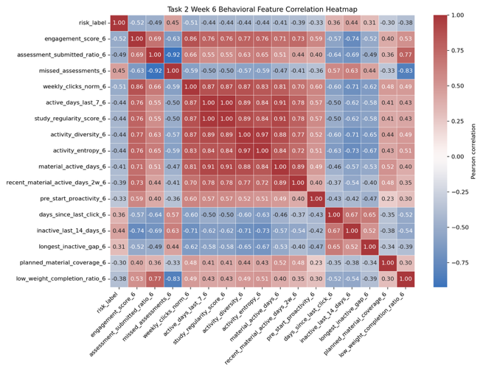
Task 2 predicts Week 6 withdraw/fail risk using a calibrated XGBoost classifier. XGBoost was selected after model comparison because it handled mixed behavioural, academic, and profile features well. Final thresholds were chosen from the precision-recall tradeoff, balancing a high-touch advisor queue with a broader watchlist for scalable support.
Model | Precision | Recall | F1 | ROC-AUC
xgboost | 0.738 | 0.842 | 0.787 | 0.863
xgboost_regularized | 0.753 | 0.817 | 0.784 | 0.858
random_forest | 0.754 | 0.816 | 0.783 | 0.857
logistic_regression | 0.773 | 0.794 | 0.783 | 0.859

True label | Predicted Pass/Distinction | Predicted Withdraw/Fail
Pass/Distinction | 2,591 (TN) | 1,256 (FP)
Withdraw/Fail | 654 (FN) | 3,648 (TP)
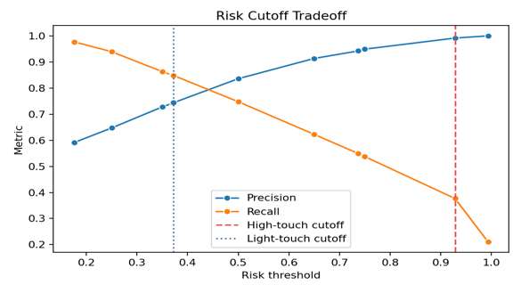
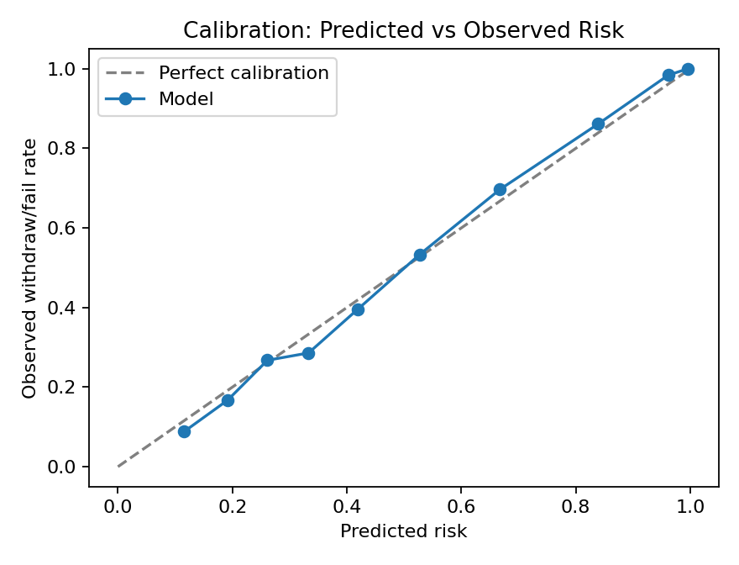

4.2 Overall Findings
Task 2 shows that Week 6 behaviour is a strong early signal of withdraw/fail risk. XGBoost was selected because it gave the best balance of recall and F1 while maintaining strong ROC-AUC. Although high recall helps reduce false negatives, an overly broad alert system can create advisor fatigue; my initial 0.968 recall required flagging 84% of students, making the alert less actionable. I therefore chose a more practical F1-recall balance.
The model is best used as an advisor prioritisation tool, where at the end of Week 6, advisors receive a ranked list of students for each course presentation. Each entry includes the student ID, course, risk score, risk tier, three plain-English reason codes, and a recommended intervention. Students in the high-touch tier are added to a live advisor queue and trigger a push notification. Students in the light-touch tier are included in a weekly digest and receive automated nudges. Students in the monitoring tier remain visible in the system, but do not require immediate advisor action.
The strongest risk drivers are early academic performance, first VLE engagement timing, and the Week 6 engagement score. Together, these capture whether a student is struggling academically, engaging late, or showing broader behavioural disengagement.

5 Task 3: Course Recommendation Engine

5.1 Approach
Task 3 produces top-3 module recommendations for students planning their next semester. The design intentionally uses two engines. Collaborative filtering is the accuracy engine for returning students with history; the content model is the explainable shared feature-space fallback and cold-start bridge.
Task 3 evaluates whether the system can recommend the correct module within the top three suggestions. The recommender was trained on earlier presentations and tested on the 2014J holdout set of 1,647 students. Two approaches were compared: a content-based recommender, which uses module and learner features, and a collaborative filtering recommender, which uses historical enrolment patterns.

5.2 Overall Findings
Metric | Result
Evaluation split | Train: 2013B/2013J/2014B, Holdout: 2014J
Holdout students | 1647
Content hit@3 | 0.354
Collaborative hit@3 | 0.468
Content coverage | 7/7
Collaborative coverage | 7/7
Cold-start modules | AAA, GGG, EEE
Actual Module | Content hit@3 | CF hit@3
AAA | 0.027 | 0.027
BBB | 0.333 | 0.400
CCC | 0.519 | 0.757
DDD | 0.046 | 0.029
EEE | 0.298 | 0.143
FFF | 0.142 | 0.065
GGG | 0.000 | 0.000

Collaborative filtering performed better overall, achieving a hit@3 of 0.468 compared with 0.354 for the content-based method. Both methods achieved full module coverage, but performance varied strongly by module. Collaborative filtering worked especially well for modules such as CCC and BBB, where historical patterns were stronger. However, content-based recommendations were more useful for some colder or sparser modules such as EEE and FFF. Overall, the results suggest that collaborative filtering should be the main recommender, with content-based logic retained as a fallback for cold-start or low-history modules.

6 Gaps, Model Risk, and 90-Day Plan

6.1 Current Gaps
- Alert load: The high-touch queue covers 20.1% high-touch, 40.1% light-touch, and 39.8% monitoring, with the top-60% watchlist capturing about 84.8% recall. This may be too broad for advisors to manage.
- Limited validation: Thresholds should be tested against real advisor capacity, not only model metrics.
- Predictive, not causal: The model flags risk but does not prove which intervention will improve outcomes.
- Small recommendation catalog: OULAD has only seven modules, so recommendation results may not generalise well.
- Robustness risk: Performance should be checked across modules and presentations, not just one split.

6.2 Model Risks
The main risk is over-alerting. If too many students are flagged, advisors may experience alert fatigue and the system may lose urgency.
There is also fairness risk. Demographic and socioeconomic features can improve prediction, but they may also reflect existing inequalities. Subgroup audits are needed before deployment.
Finally, the recommendation layer is still early-stage. Real course guidance should include prerequisites, course capacity, difficulty, student preferences, and progression history.

6.3 90-Day Improvement Plan
Over the next 90 days, the focus should be on validation, model robustness, and operational readiness. In Days 0–30, the priority is to strengthen the evidence base through model cards, calibration reports, leakage checks, fairness audits, capacity simulations, and reproducible artifacts. In Days 31–60, the modelling layer should be improved by comparing logistic regression, XGBoost/LightGBM, and survival-style models, refining thresholds, adding explanations, and testing stability across presentations. In Days 61–90, the system should move toward pilot deployment by testing advisor workflows, logging interventions and outcomes, measuring uplift, monitoring drift, and improving recommendations with real-world constraints.

6.4 Final Stance
The final reviewer-facing stance should be clear: this report presents a leakage-safe, advisor-actionable prototype that turns behavioural data into prioritised support decisions and initial course guidance. It is ready for controlled pilot validation, but it should not yet be described as a fully autonomous deployment. The strongest contribution is the engagement framework feeding a Week 6 risk model, while the weakest link is still recommendation generalisability. The next phase should therefore focus on validation, monitoring, and intervention effectiveness rather than simply adding more cosmetic features.

